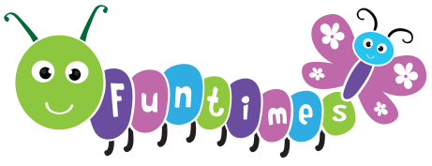

Food and Nutrition information for parents/carers

Funtimes everyday healthy eating
At Funtimes we are committed to supporting children’s health and wellbeing by promoting a positive, safe approach to food and nutrition.
We support children to eat a balanced diet to include:
- Fruit and vegetables (apples, carrots, bananas, melon)
- Protein (fish, eggs, meat)
- Dairy (yogurt, milk, cheese)
- Water or milk only

Packed lunch
- As we promote healthy eating, please include food from list above. We encourage parents to avoid putting foods like chocolate or sweets in their pack lunches.
- Children should only have water in their drink bottles that they bring in - please speak to a member of staff if any problems with this.
- Parents are asked to cut up food that may be a choking risk e.g. grapes, cherry tomatoes, berries, cocktail sausages.
Popcorn is not allowed as the jagged kernel pieces are a major choking hazard.
- We are a nut free setting, so no food containing nuts will be allowed.
- If we have any concerns about the pack lunches, then we would discuss with you privately, and never in front of your child or another parent.

Allergies and special diets

- Parents must inform us of all allergies, intolerances or dietary requirements for their child.
- All allergy information is shared with staff and staff are trained to manage allergies safely.
- We have a display board where all allergies, intolerances, or dietary needs will be available for staff to see at all times.
- If a child has an allergy, intolerance or dietary requirement, then this will also be displayed on the food mats of each keyworker and displayed on every table.

Birthdays and Celebrations
- We celebrate birthdays in an inclusive way through songs, games and fun activities.
- To support healthy eating, parents may contribute non-food items like stickers, bubbles or a book for their child’s birthday, if they wish to.
- If a parent wants to bring in a food treat, then this must be suitable for all children and store bought where a full list of ingredients are available. All food brought in for a birthday will be given out to parents at the end of the day and never to a child. Cultural and religious food traditions are celebrated where safe and appropriate

Our promise to Safeguarding and Equality
- Mealtimes will be in a calm environment, where children can be social and enjoy the experience.
- Children will not be pressured to eat food they do not want.
- Children’s lunches will not be compared.
- A member of staff will always be sat with children while they are eating.
- Staff will never comment negatively on a child’s food in front of them.
- Ongoing discussions between staff and parents about managing allergies and intolerances must take place.
- There will always be someone with a valid paediatric first aid certificate in the room where children are eating.
- This policy will be reviewed annually, and input will be asked from staff and parents, keeping in line with EYFS guidelines.

By working together, we can ensure that children get the best relationship with food, keeping them healthy and enjoy mealtimes.

